An
Intership Report
On

Educational Organisation Using ServiceNow

Name : S. Imran Ali
Roll No: 23BFA01L27
Branch: Civil Engineering
College: S V College of Engineering

INTRODUCTION

Project Overview:
The project titled "Educational Organisation Using ServiceNow" is designed to automate and streamline the administrative workflows of educational institutions. Built on the
ServiceNow platform, it facilitates student admissions, academic progress tracking, and smart form-based workflows using no-code/low-code configurations.

Purpose:
To minimize manual intervention in educational data handling and build a centralized digital system for managing student records, tracking performance, and enhancing administrative efficiency.

IDEATION PHASE

Problem Statement:
Manual tracking of student admissions and academic progress is time-consuming and error-prone. There is a need for a centralized digital platform to manage these operations efficiently.

Empathy Map Canvas:
- Users: School Admins, Admission Coordinator
- Needs: Quick data access, automated workflows
- Pains: Time delays, repetitive data entry
- Gains: Real-time dashboards, auto-calculated results, form-level automation

Brainstorming Highlights:
  - Use existing cloud platform – ServiceNow
  - Leverage personal developer instance
  - Design scalable custom tables and relationships
  - Use client scripts for automation
  - Implement dynamic defaults, choices, and workflow logic

REQUIREMENT ANALYSIS

Customer Journey Map:
  - Admin logs into ServiceNow
  - Navigates to Admission module
  - Fills student data (with auto-filled fields)
  - Views student performance
  - Processes admission status using workflows

Solution Requirements:
- Custom tables: Salesforce, Admission, Student Progress
- Forms, views, and layouts configuration
- Automation using Client Scripts
- Admission lifecycle managed through workflow
Data Flow Diagram
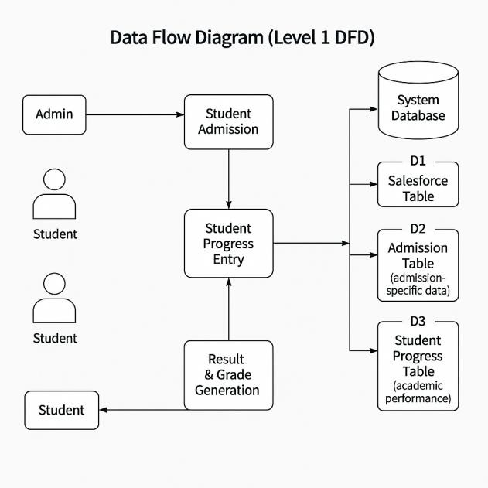
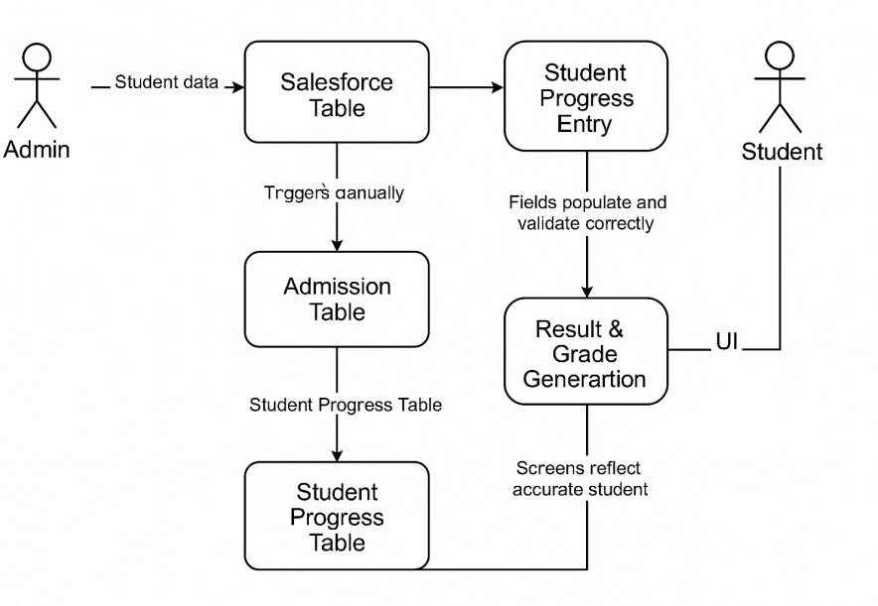

Technology Stack:

Component | Technology
Platform | ServiceNow Personal Developer Instance
Scripting | JavaScript (Client Scripts)
Database | ServiceNow Tables
Workflow | Process Flow in ServiceNow UI

PROJECT DESIGN

Problem-Solution Fit:
Digitizing admission and academic workflows saves time, reduces errors, and provides administrative transparency.

Proposed Solution:

An integrated education management solution with modules to:
- Manage student admissions
- Record student progress
- Automate calculations and validations

Solution Architecture:

ServiceNow-based architecture includes:
- Custom table design
- Form-level UI configuration
- Process flow design
- Client-side GlideForm scripting

PROJECT PLANNING & SCHEDULING
Timeline Plan:

Week | Activities
Week 1 | Instance Setup & Update Set Creation
Week 2 | Table & Field Design
Week 3 | Form Layouts & Views
Week 4 | Process Flow & Client Scripts
Week 5 | Testing & Documentation

FUNCTIONAL & PERFORMANCE TESTING

Performance Testing Metrics:
- Field-level automation is responsive within 1 second
- Script triggers execute and validate as expected
- Record creation/update latency is < 1 second

RESULTS
Output Screenshots:
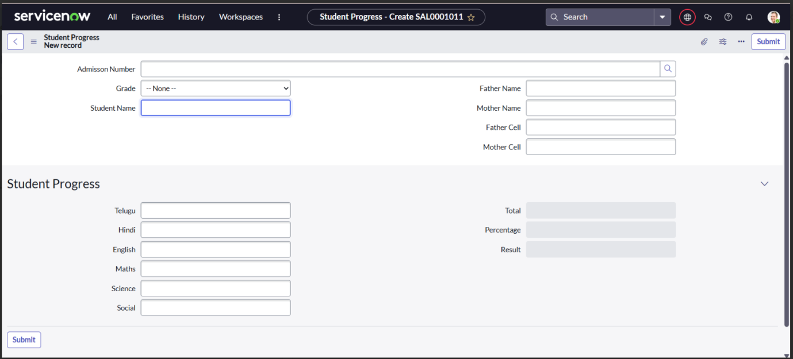

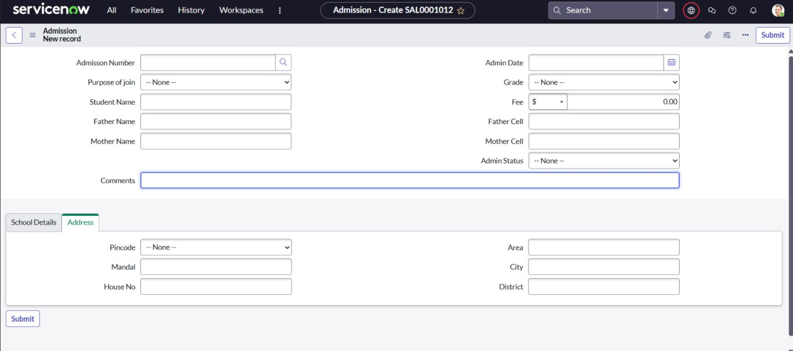

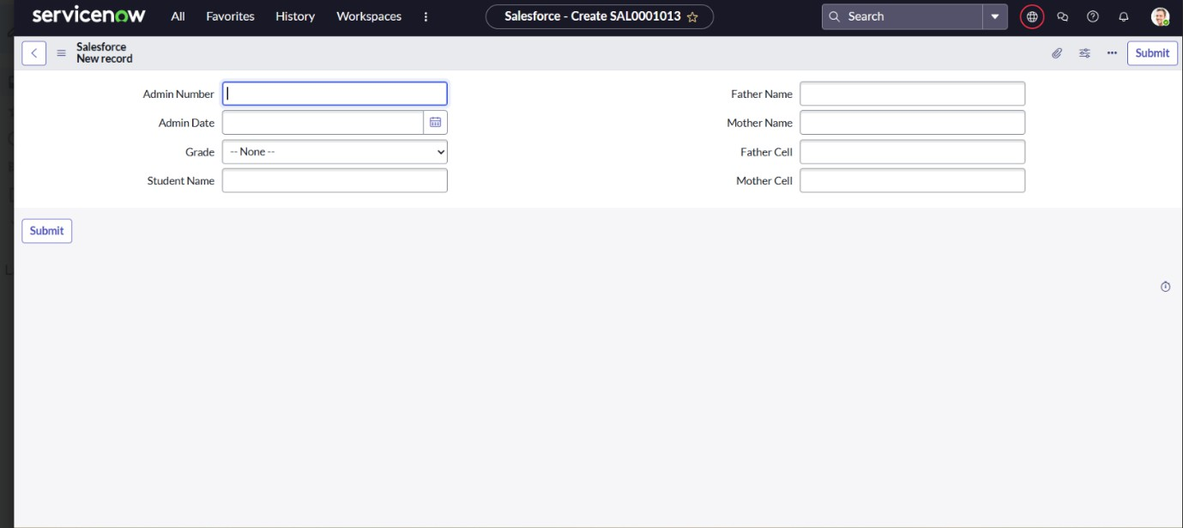

ADVANTAGES & DISADVANTAGES

Advantages:
⬛ Cloud-based, no installation needed
⬛ Easy form and workflow customization
⬛ Low-code development with fast deployment
⬛ Real-time data updates

Disadvantages:
+ Requires internet connectivity

+ Limited advanced UI customization
+ Requires basic familiarity with ServiceNow

CONCLUSION
This project demonstrates the potential of low-code platforms like ServiceNow in digitizing real-world administrative functions. It enhances efficiency, reduces human errors, and offers scalable solutions for educational institutions.

FUTURE SCOPE
- Add modules for teacher and staff management
- Integrate notification system (email/SMS)
- Real-time dashboard analytics
- Fee and library management integration

APPENDIX
- Source Code:
Below are the key Client Scripts used in the application:

Auto-Generate Admission Number

javascript CopyEdit
function onLoad() {
var date = new Date();
var uniqueID = 'ADM' + date.getTime(); g_form.setValue('admission_number', uniqueID);
}

Auto-Fill Address Based on PIN

javascript CopyEdit
function onChange(control, oldValue, newValue, isLoading) { if (isLoading || newValue == '') return;

if (newValue === '500001') { g_form.setValue('state', 'Telangana'); g_form.setValue('district', 'Hyderabad');
}
}

Calculate Total Marks, Percentage, Result

javascript CopyEdit
function onChange(control, oldValue, newValue, isLoading) { if (isLoading) return;
var marks1 = parseInt(g_form.getValue('subject1') || 0); var marks2 = parseInt(g_form.getValue('subject2') || 0); var marks3 = parseInt(g_form.getValue('subject3') || 0);
var total = marks1 + marks2 + marks3; var percent = total / 3;

g_form.setValue('total_marks', total); g_form.setValue('percentage', percent.toFixed(2)); g_form.setValue('result', percent >= 35 ? 'Pass' : 'Fail');
}

OnLoad – Set Default Admission Status

javascript CopyEdit
function onLoad() {
g_form.setValue('status', 'Application Received');
}

Disable Fields After Admission Finalized

javascript CopyEdit
function onChange(control, oldValue, newValue, isLoading) { if (isLoading) return;
if (newValue === 'Admission Confirmed') { g_form.setReadOnly('student_name', true); g_form.setReadOnly('dob', true); g_form.setReadOnly('email', true);
}
}

Show Alert on Form Submission

javascript CopyEdit
function onSubmit() {
alert('Your application has been submitted successfully!'); return true;
}
  - GitHub Repository: https://github.com/mani-chandrika549/Educational- Organisation-using-Service-Now
  - DemoVideo:https://drive.google.com/file/d/16oozaZLHFgpER5Fd7pnexuqMT7qg1D OA/view?usp=sharing

